10 SCIENCE 2016

BIOLOGY TEST ONE: DNA

Name: ____________________ Teacher: ___________________ Mark: /53

Percentage: %

SECTION A: MULTIPLE CHOICE (5 marks)

Select the most correct answer for each question below.

1. DNA is made up of molecules called:

(a) proteins.
(b) genes.
(c) chromosomes.
(d) nucleotides.

2. Choose the most correct statement about proteins.

(a) Proteins control many characteristics and functions in the body.
(b) Proteins include the structural materials that build up your cells and tissues.
(c) Proteins are long threadlike structures found in the nucleus of cells.
(d) Proteins make up most of the hormones in the human body.

3. The function of DNA is to:

(a) allow the cells of a living thing to reproduce.
(b) allow complementary nitrogen-rich bases to pair up.
(c) store information on how a living thing’s cells and body will work and look.
(d) store nucleotides in the nucleus of a cell.

4. The diploid number of chromosomes is:

(a) 23 chromosomes.
(b) 42 chromosomes.
(c) 46 chromosomes.
(d) 24 chromosomes.

5. Choose the correct statement.

(a) DNA strands have a special shape called a twisted ladder.
(b) The nucleus is part of the cell that produces energy.
(c) DNA is short for Designer Nucleic Acid.
(d) Chromosomes are tightly coiled DNA threads.

SECTION B: SHORT ANSWER (48 marks)

1. Explain the difference between a gene and a chromosome. (2 marks)

_____________________________________________________________________________________

_____________________________________________________________________________________

_____________________________________________________________________________________

2. State what the initials DNA represent. (1 mark)
Beryllium

_____________________________________________________________________________________

3. Label the diagram of the nucleotide below. (3 marks)

4. The chemical structure of the nitrogen-rich bases means that they can only form chemical bonds with one of the other bases. (2 mark)

_______________________ only pairs with __________________________

_______________________ only pairs with __________________________

5. Fill in the missing words. (6 marks)

The general cells in the human body each contain __________ chromosomes or __________ pairs.

The only exceptions are the _________________ and ___________________ cells which only contain

_________ chromosomes and red blood cells which have no ____________________.

6. Write the complimentary DNA strand underneath each given strand of DNA. (2 marks)

a. C G T A A G C G C T A A T T A
_________________________________________
b. T C T T A A A T G A T C G A T C
_________________________________________
7. Write definitions for the terms below. (2 marks)

Meiosis: _____________________________________________________________________________

_____________________________________________________________________________________

_____________________________________________________________________________________

Replication: ___________________________________________________________________________

_____________________________________________________________________________________

8. Contrast (state 3 differences between) sexual and asexual reproduction. Write in full sentences. (3 marks)

_____________________________________________________________________________________

_____________________________________________________________________________________

_____________________________________________________________________________________

_____________________________________________________________________________________

_____________________________________________________________________________________

_____________________________________________________________________________________

_____________________________________________________________________________________

_____________________________________________________________________________________

9. State one advantage of sexual reproduction. (1 marks)

_____________________________________________________________________________________

10. State one disadvantage of sexual reproduction. (1 mark)

_____________________________________________________________________________________

11. Circle either true or false for the statements below. (6 marks)

a. Meiosis occurs in gametes. True / false
b. Mitosis produces four daughter cells. True / false
c. Each chromosome is a gene strand tightly coiled up. True / false
d. A fertilised egg is known as a zygote. True / false
e. Meiosis produces general body cells. True / false
f. Sex chromosomes determine the sex of an individual. True / false
12. Complete the table below. (6 marks)

Phase of mitosis | What is happening | Diagram
Interphase | ●   DNA replicates.   | 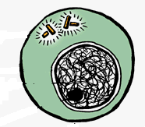
 | ⬧ Nuclear membrane breaks down.     | 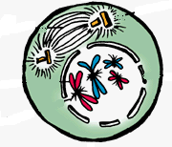
 | ⬧   | 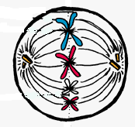
 | ⬧ Chromosomes split and move to opposite  poles of the cell. | 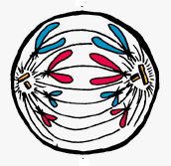
Telophase | ⬧   | 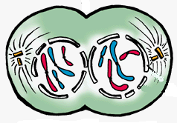
 | ⬧   Two daughter cells are formed. | 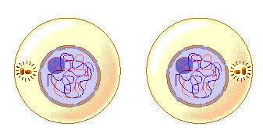

13. Complete the table below. (10 marks)

Comparison of mitosis and meiosis
 | Mitosis | Meiosis
The type of cells this occurs in

The number of daughter cells that are
produced
The number of divisions

Are the daughter cells genetically
identical to the parent cells? (Yes/no)
The number of chromosomes in each
produced cell

14. Complete the diagram below. (3 marks)

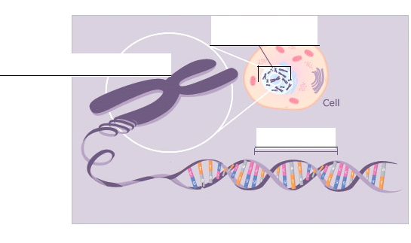
Please read over all your answers checking that you have attempted each of them to the best of your ability.
Check your grammar and spelling.

Only do this when you have FINISHED and CHECKED your test
